CS 1050, Mr. Kramer Sample Exam #1, p. 1 of 8 Total 160 points

Put your answers in the space provided.

1. a. ______ -8 * 5 / 2 * 2

b. ______ 85 % 10 / 2.0 + 4

c. ______ 10 / 4 * 3 – 2 + 17 % 5

d. ______ 15.0 / 2 * 2 + 15 / 7

2. 12 pts. In each part, use the code to fill in the values. Use a ? if the value is not determined by the code.

a. int a = 1, b = 7, c = 5;

a = b + 4; c = 4; a ______ b ______ c ______

b. int a = 11, b = 3; float c = 1.0F;

c = a/b; b = ++a; a ______ b ______ c ______

c. int a = 2, b = 4, c = 8;

a = b++ + c++; a ______ b ______ c ______

In #3 and #4, you can use T for true and F for false.

3. 5 pts. Evaluate the following Java logical expressions using C = true,

D = true. E = false, F = false. Place answer on the line.

a. ______ E || D && C || D

b. ______ E && F || C && D

c. ______ ! D || C

d. ______ F || C && !E

e. ______ ! (E || D) && C

4. 8 pts (2 pts each). Fill in the truth value for the Java expression depending on the value of x.

Expression Value of x

| 0 | 3 | 5 | 7 | 8 |

–––––––––––––––––––––––––––––––––––––––––––––––––––––––––––––––––––––––

x < 7 || x == 3 && x == 7 || x > 3 | | | | | |

–––––––––––––––––––––––––––––––––––––––––––––––––––––––––––––––––––––––

x == 3 || x > 3 && x > 7 || x == 7 | | | | | |

–––––––––––––––––––––––––––––––––––––––––––––––––––––––––––––––––––––––

x == 3 || x < 7 && x > 3 || x == 7 | | | | | |

–––––––––––––––––––––––––––––––––––––––––––––––––––––––––––––––––––––––

x < 3 || x > 7 && x == 7 || x == 3 | | | | | |

–––––––––––––––––––––––––––––––––––––––––––––––––––––––––––––––––––––––

CS 1050, Mr. Kramer Sample Exam #1, p. 2 of 8

5. 32 pts (8 pts each part). Write Java code to implement the following.

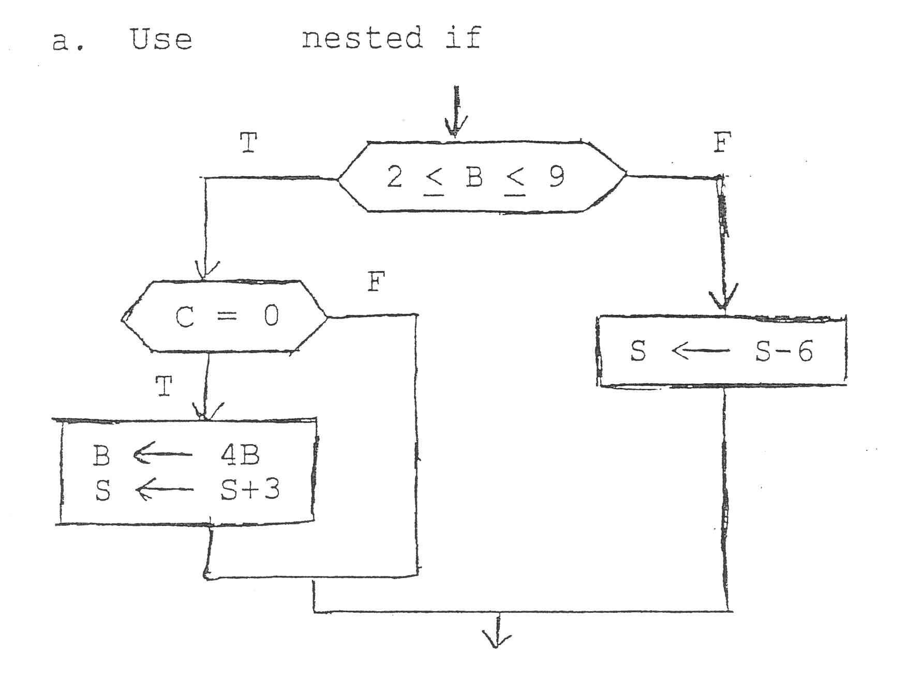

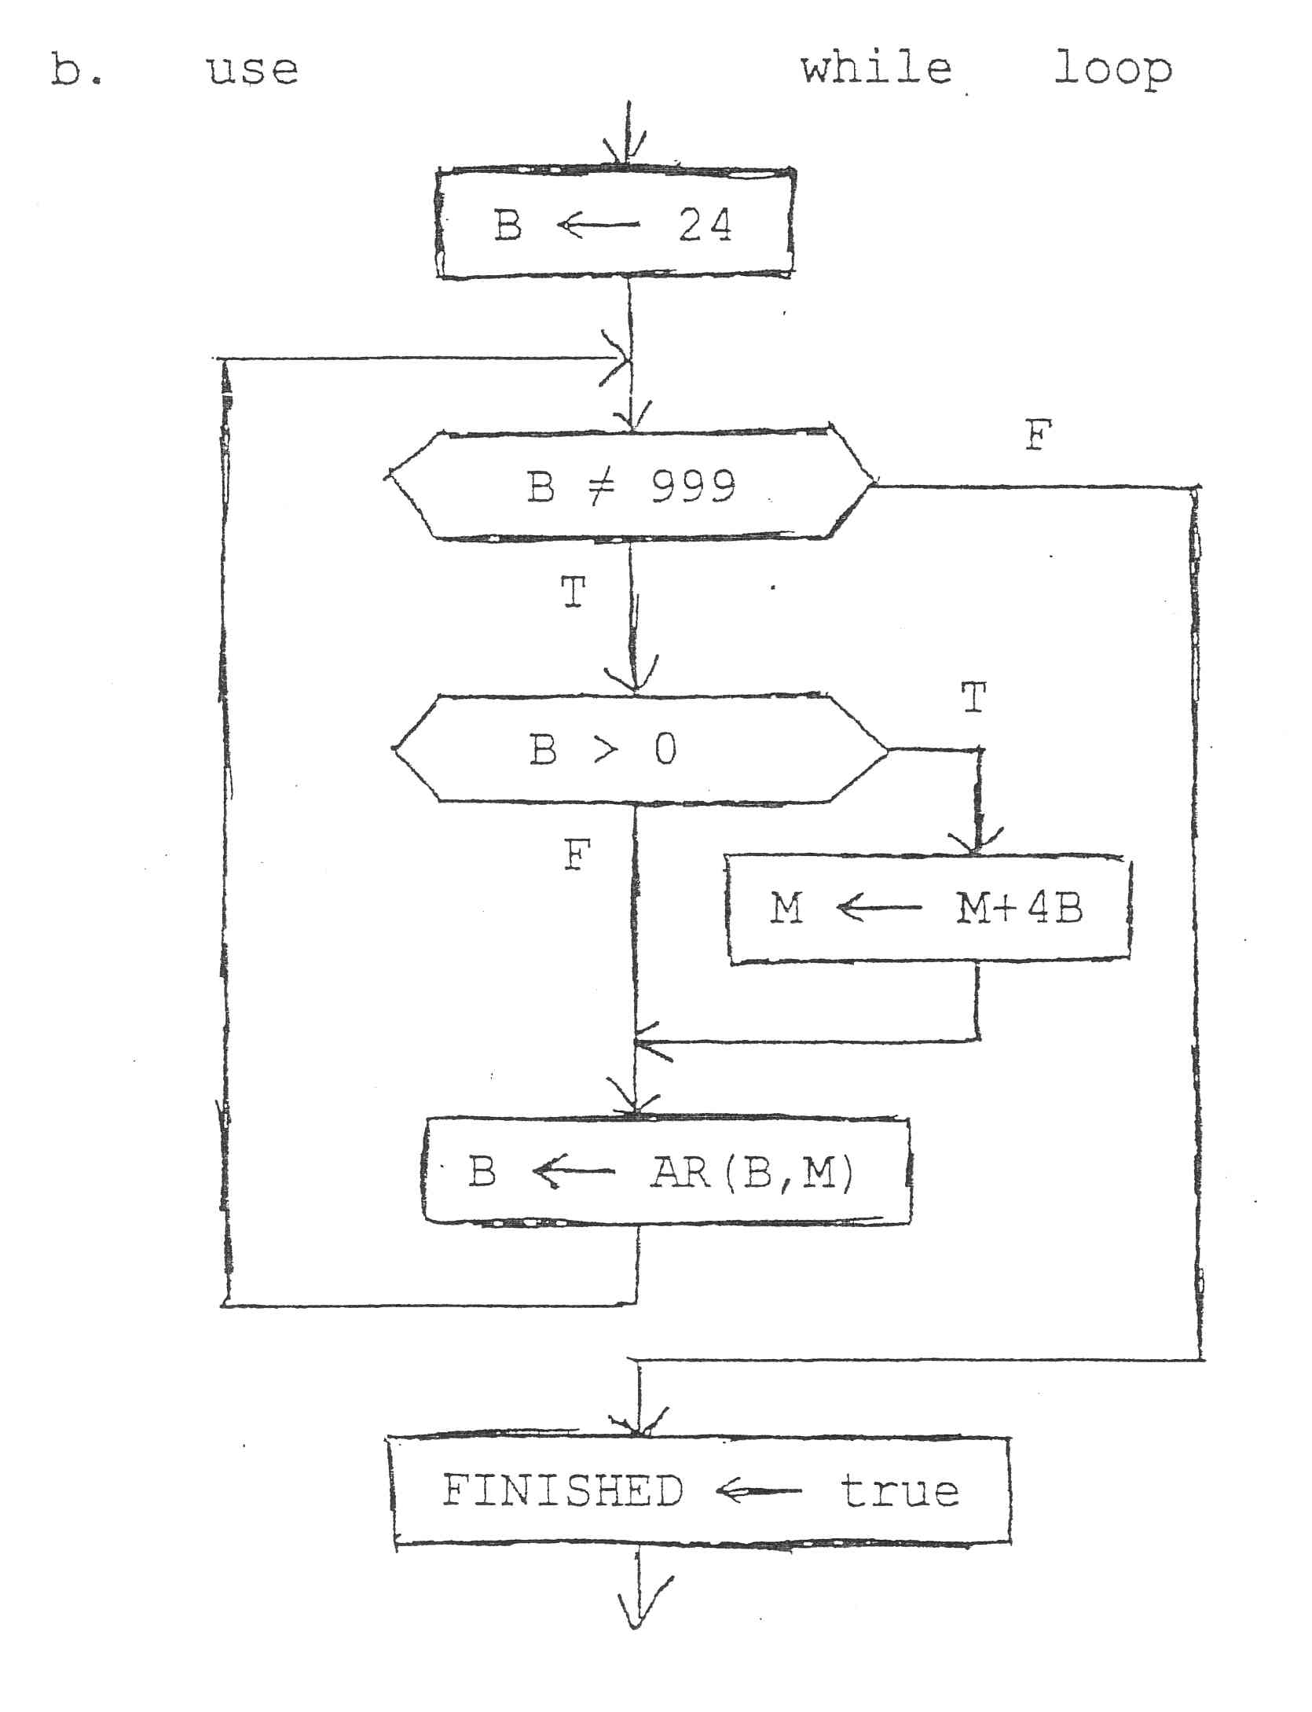

CS 1050, Mr. Kramer Sample Exam #1, p. 3 of 8

5. (continued) Write Java code to implement the following:

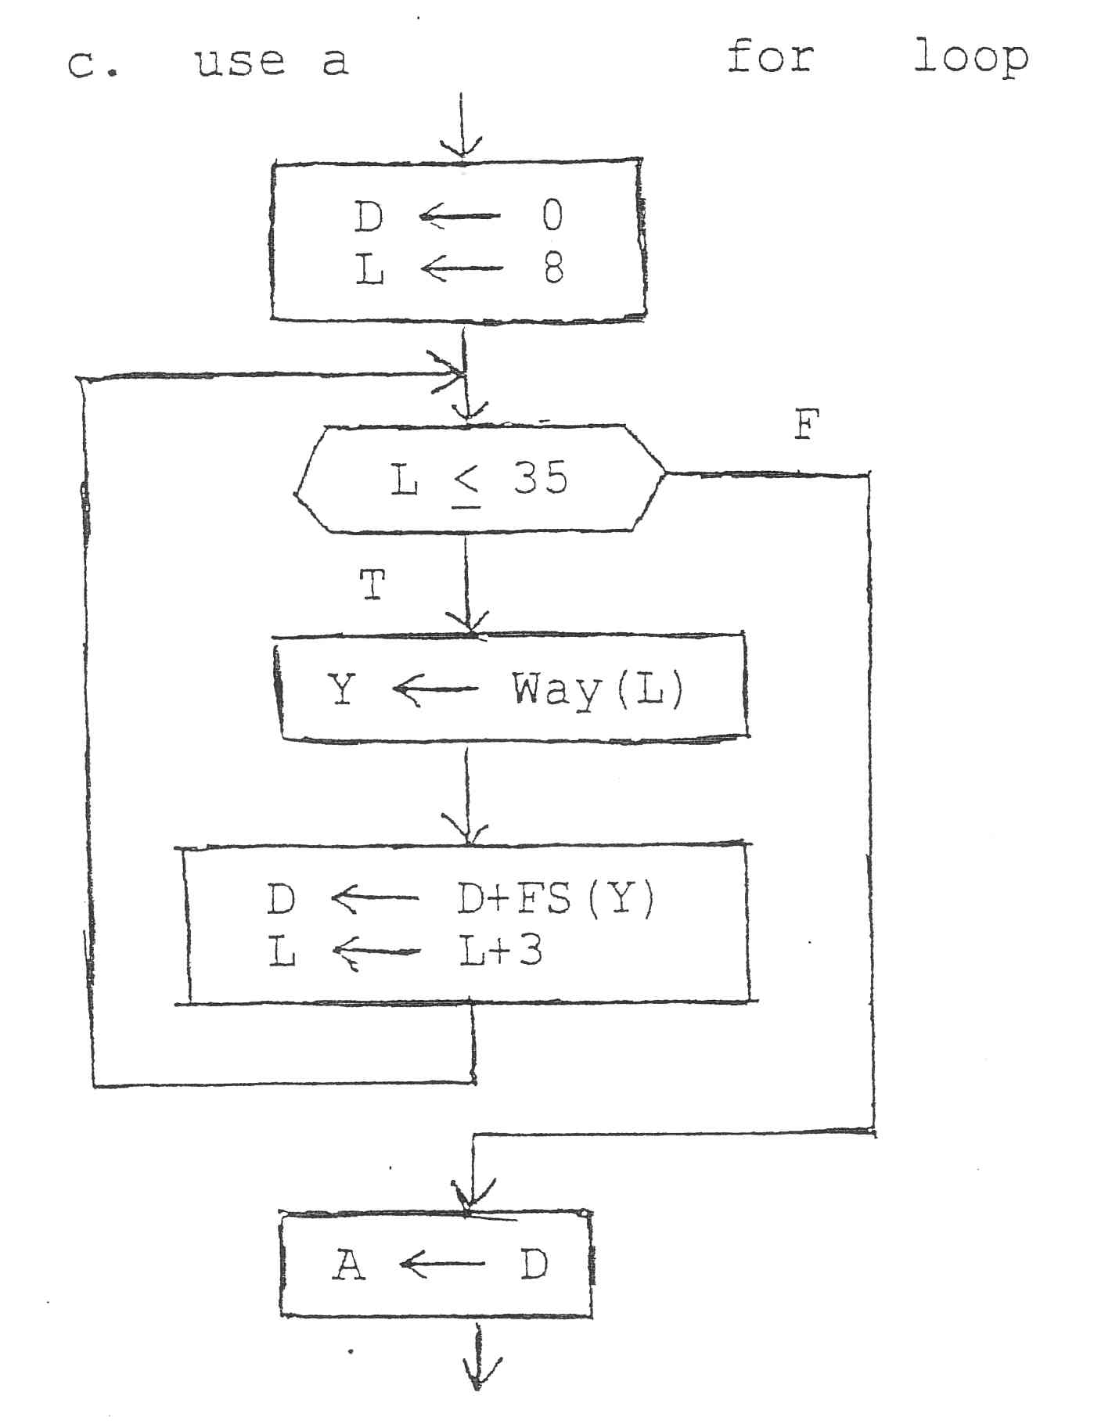

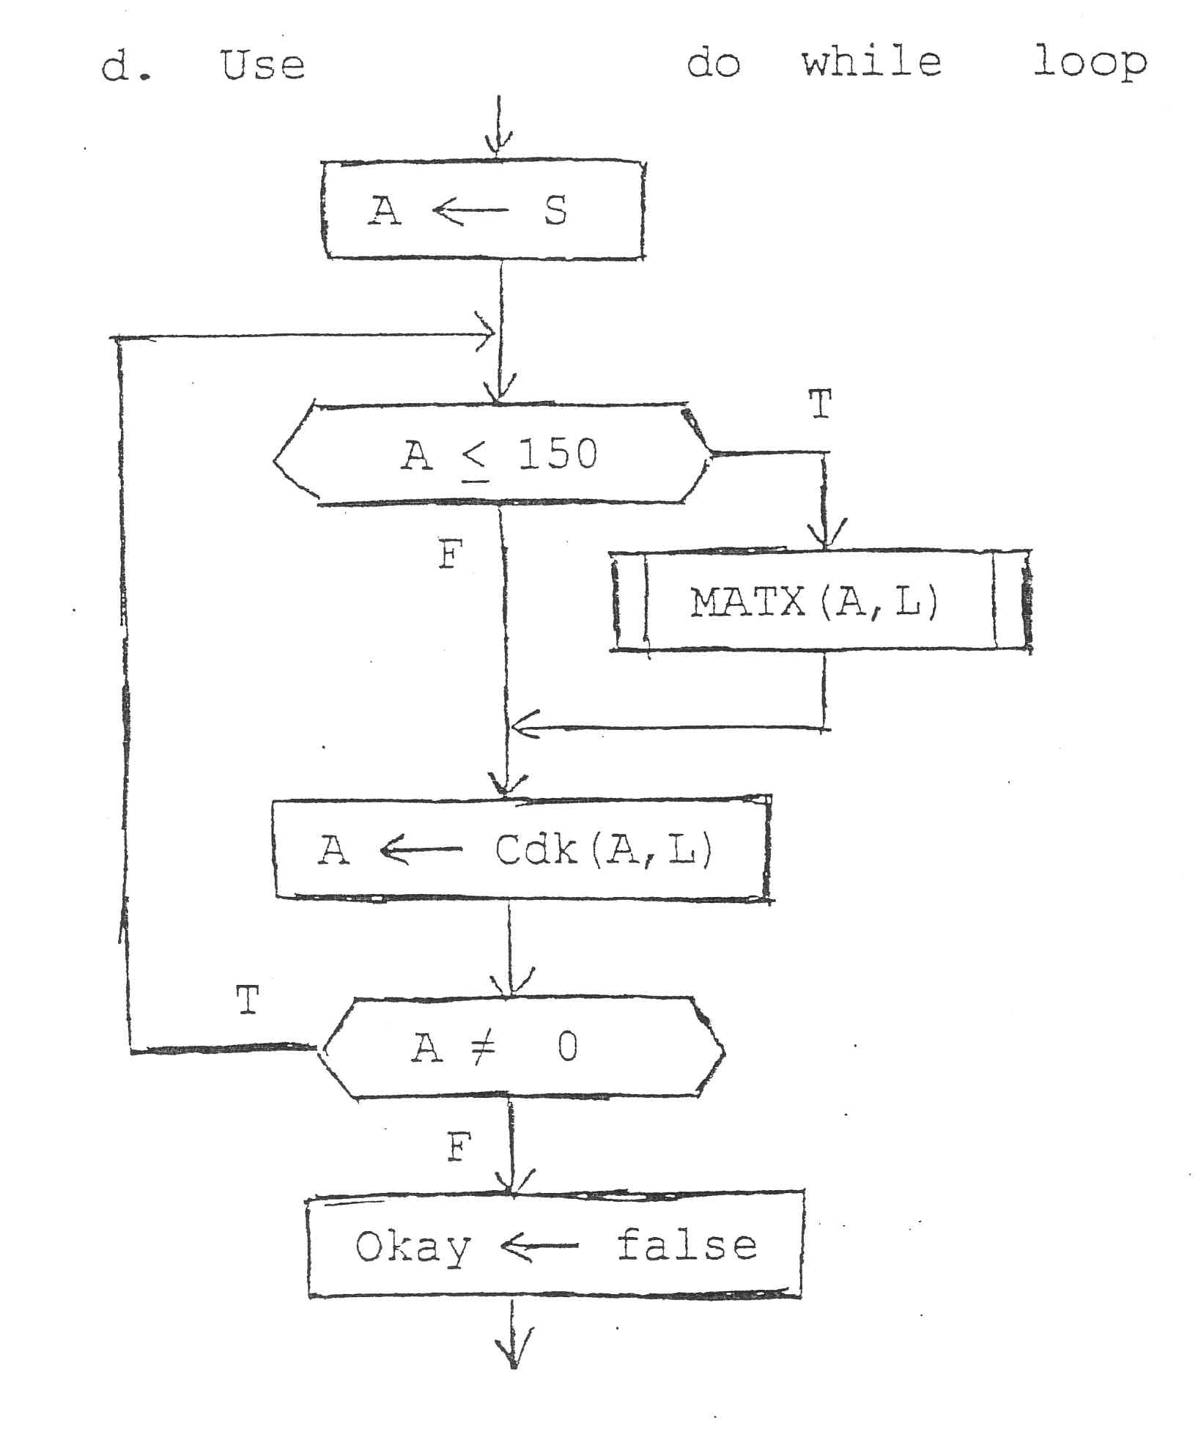

CS 1050, Mr. Kramer Sample Exam #1, p. 4 of 8

6. 16 pts. Use the flowcharts to determine the answers and put them in the space provided. Show work, include memory boxes.

ADD B <- 0 after Start

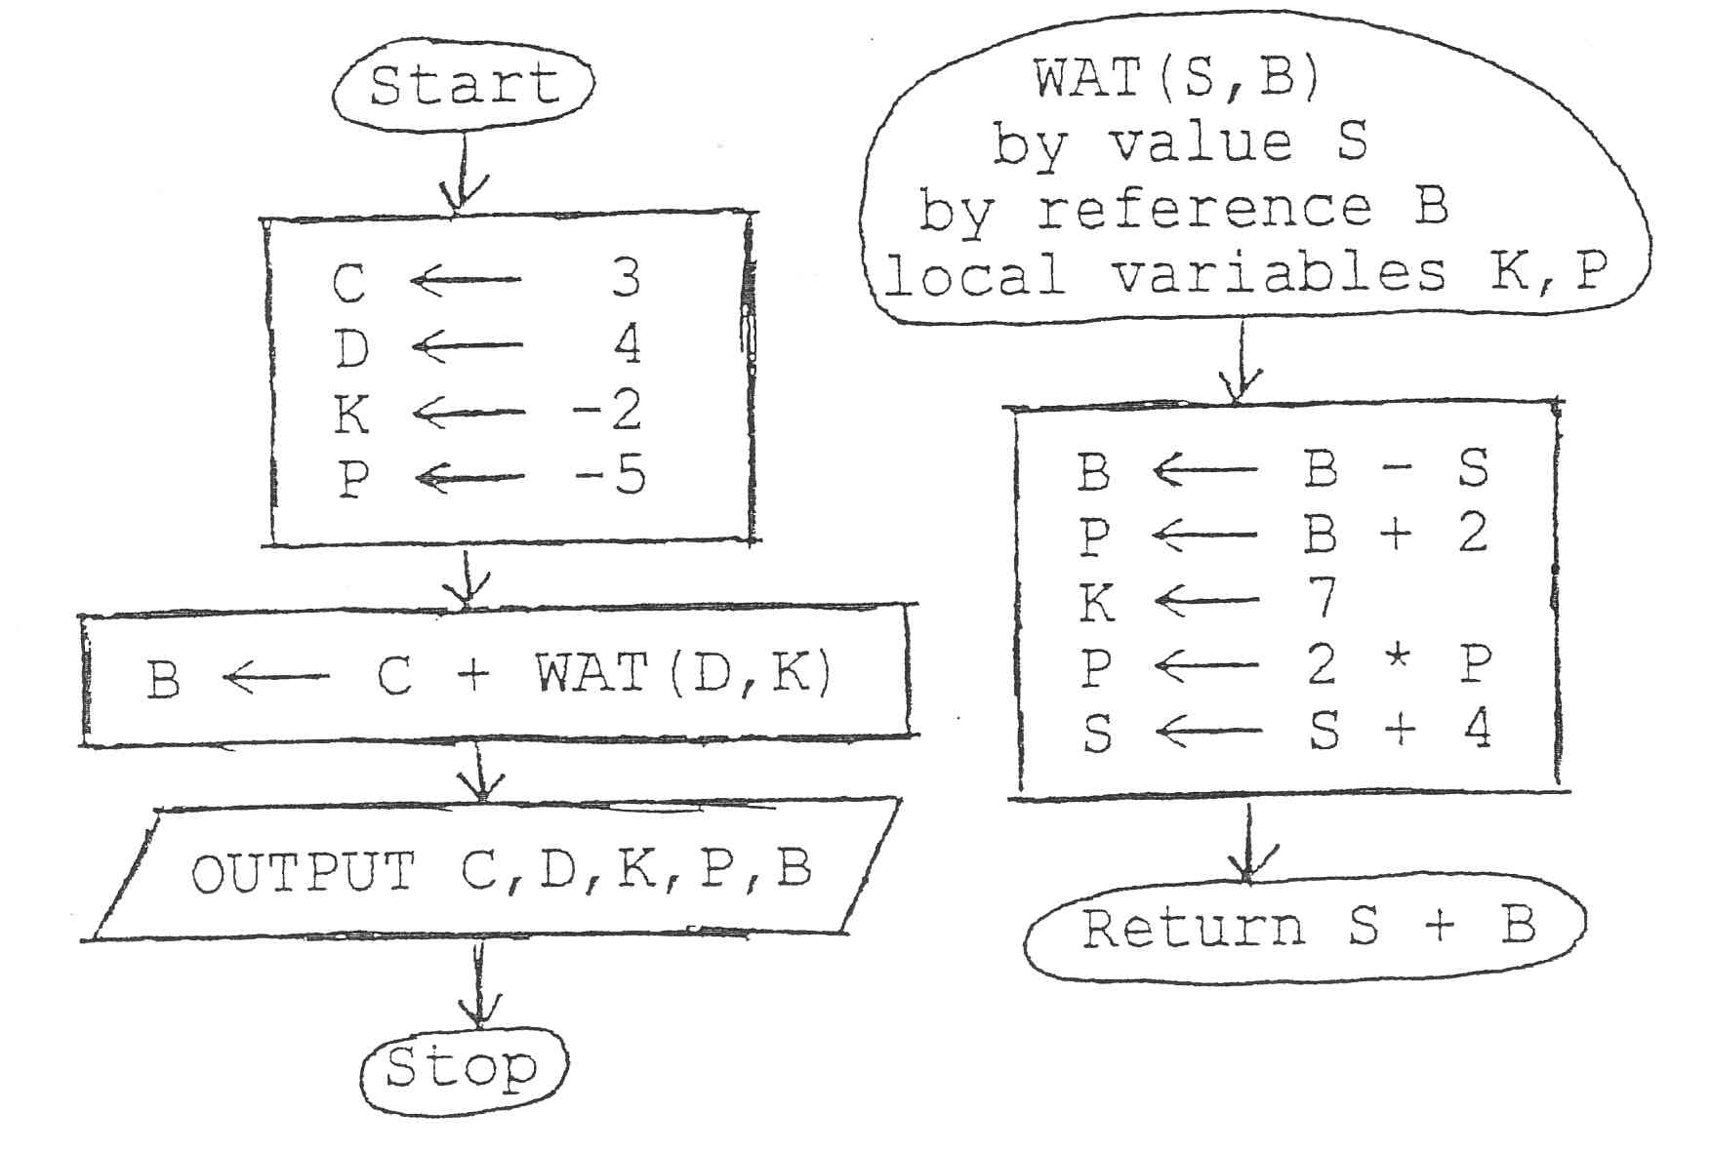

a. The actual parameters are ________________________________________

b. The formal parameters are ________________________________________

c. The output produced is _____ _____ _____ _____ _____

7. 16 pts. Use the flowcharts to determine the answers and put them in the space provided. Show work, include memory boxes.

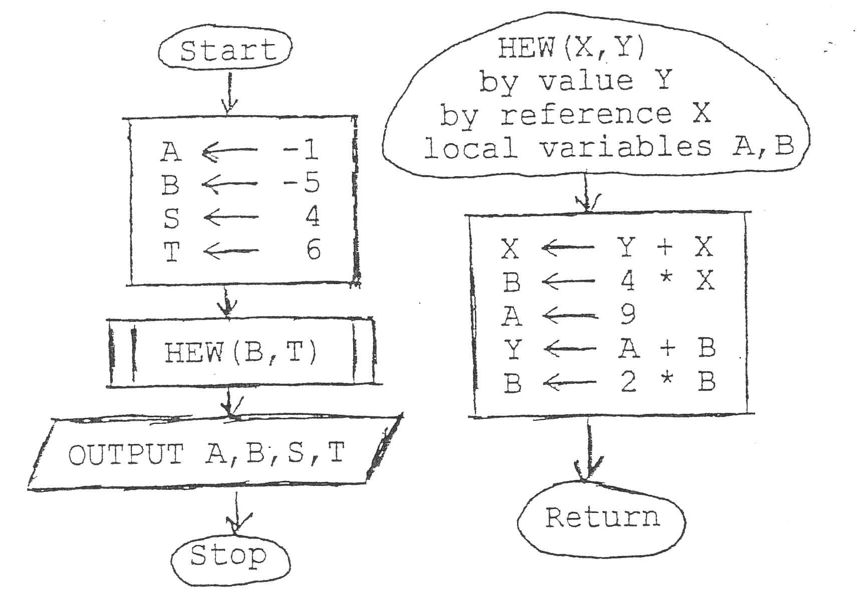

a. The actual parameters are ________________________________________

b. The formal parameters are ________________________________________

c. The output produced is _____ _____ _____ _____

CS 1050, Mr. Kramer Sample Exam #1, p. 5 of 8

6. 16 pts. Use the flowcharts to determine the answers and put them in the space provided. Show work, include memory boxes.

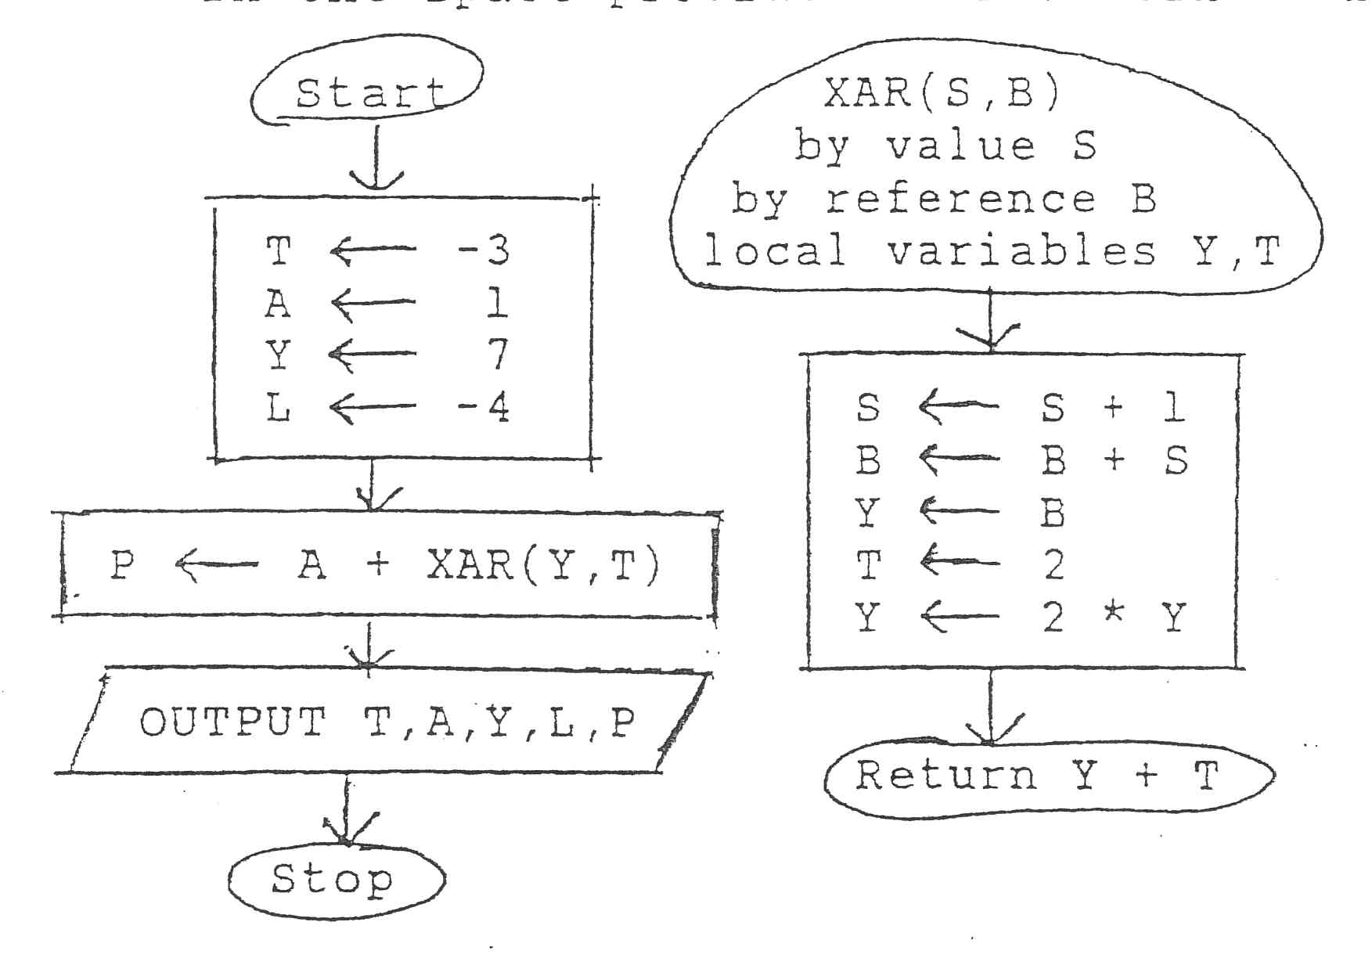

a. The actual parameters are ________________________________________

b. The formal parameters are ________________________________________

c. The output produced is _____ _____ _____ _____ _____

7. 16 pts. Use the flowcharts to determine the answers and put them in the space provided. Show work, include memory boxes.

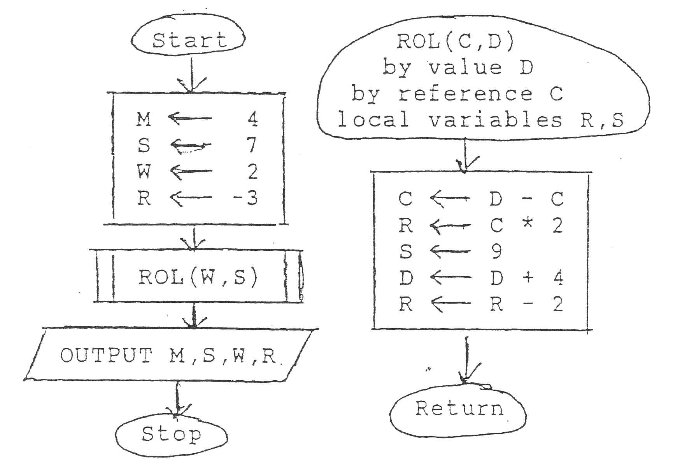

a. The actual parameters are ________________________________________

b. The formal parameters are ________________________________________

c. The output produced is _____ _____ _____ _____

CS 1050, Mr. Kramer Sample Exam #1, p. 6 of 8

6. 16 pts. Use the flowcharts to determine the answers and put them in the space provided. Show work, include memory boxes.

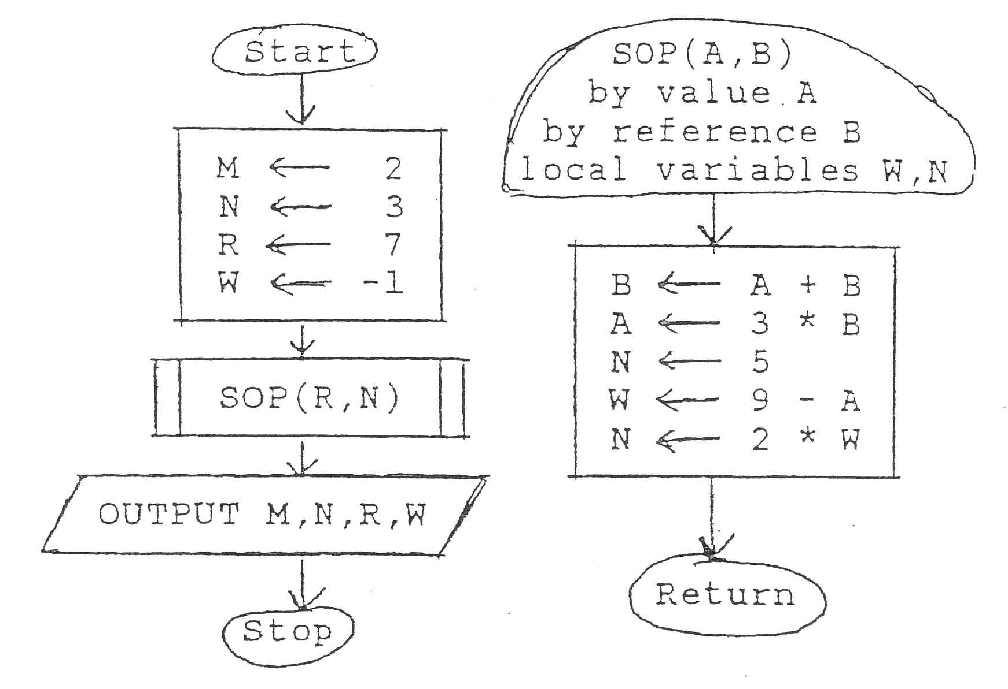

a. The actual parameters are ________________________________________

b. The formal parameters are ________________________________________

c. The output produced is _____ _____ _____ _____

7. 16 pts. Use the flowcharts to determine the answers and put them in the space provided. Show work, include memory boxes.

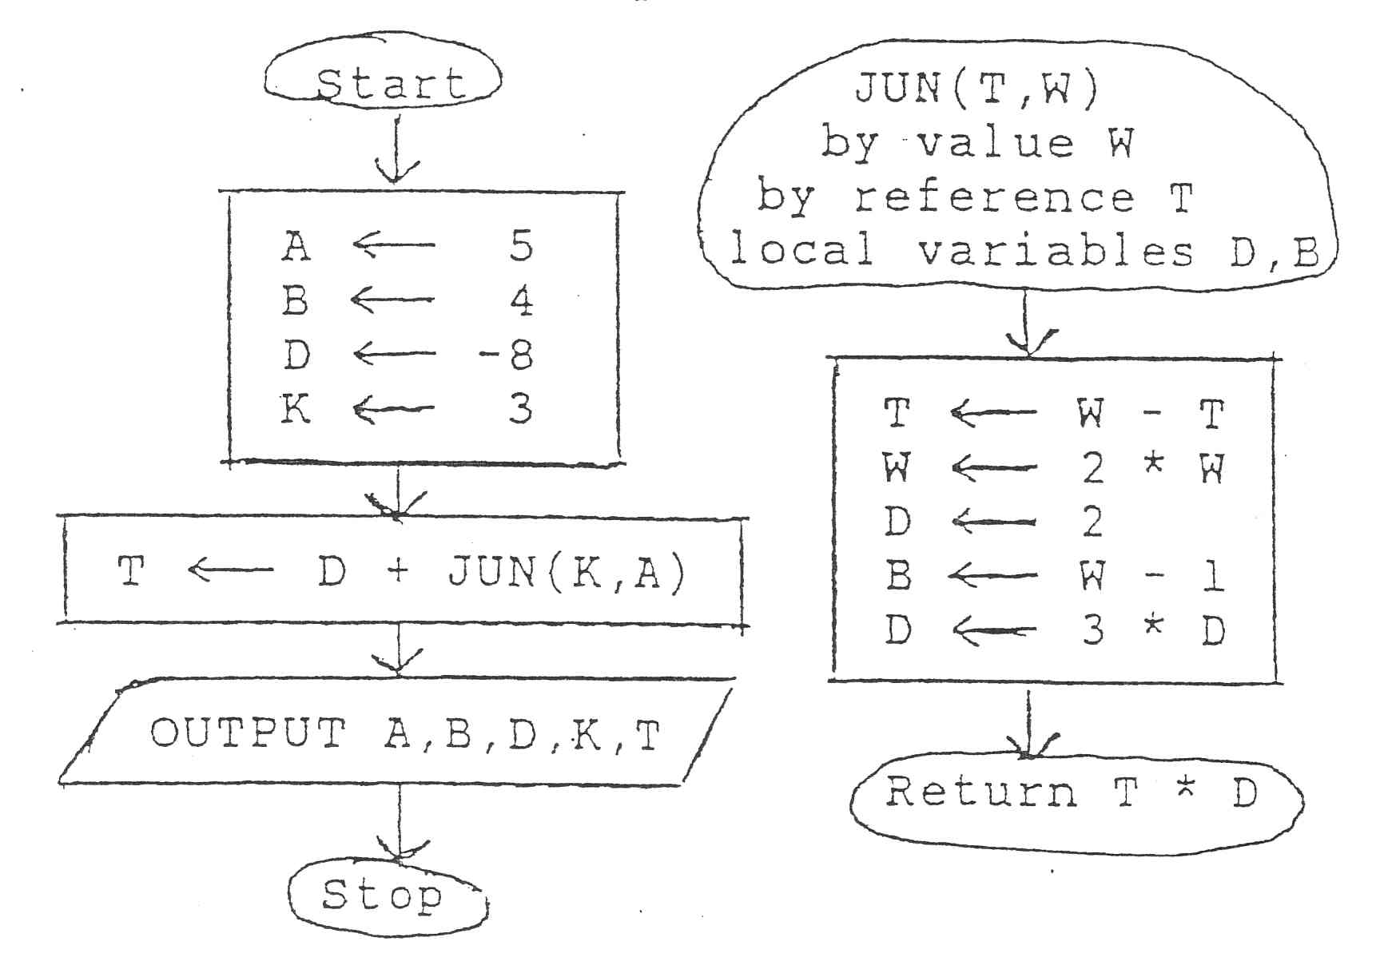

a. The actual parameters are ________________________________________

b. The formal parameters are ________________________________________

c. The output produced is _____ _____ _____ _____ _____

CS 1050, Mr. Kramer Sample Exam #1, p. 7 of 8

8. 16 pts. Write a Java switch statement which does exactly one of the following:

if the value of B is 5 or 7, add 2 to B;

if the value of B is 8, assign the value 0 to CORRECT;

if the value of B is 4, assign the word OKAY to Msg and then execute the void method Proc(B)

Default is to assign the word “invalid” to Msg

9. 8 pts. Rewrite to equivalent Java code using “while”

do

{ B = B + FN(B);

B = Find(B); }

while (B != 100);

10. 10 pts. Write a Java method AB which corresponds to the call AB(b,a) where a and b are integers and the method returns the real weighted average of a and b obtained by adding 2 times b and 4 times a and dividing the result by 6.

CS 1050, Mr. Kramer Sample Exam #1, p. 8 of 8

11. 28 pts. Write a complete Java program that will compile correctly using “main” as the only method that will do the steps below. (comments and formatting are unnecessary).

Include in your code before the main method

static Scanner console = new Scanner(System.in);

a. Prompt the user to input two real numbers, one per line

b. Read the two numbers

c. Calculate the real weighted average of the two numbers: add 2 times the first number and 4 times the second number and divide the result by 6

d. Print the two numbers with a message on one line and then their weighted average with a message on the next line

e. Print a blank line and then your name